1. 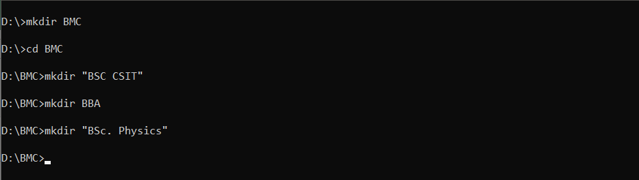Creating BSC CSIT, BBA, Bsc. Physics directories inside BMC
2. Creating a file info.txt inside BSC CSIT containing name of 10 students

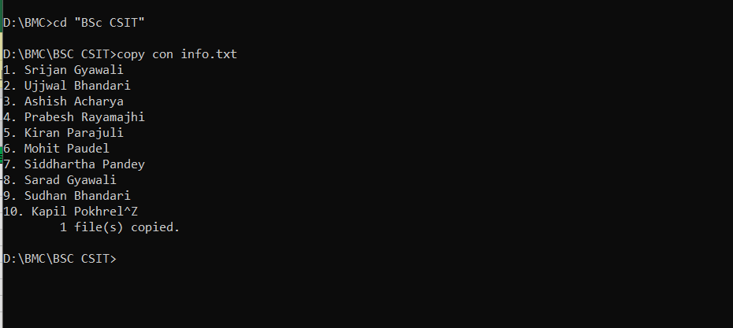

1. Renaming the file info.txt to sectionA.txt

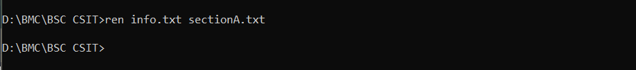

1. Hiding the file sectionA.txt

